**HTML Tutorial: Semantic Tags in HTML| Web Development Tutorials #12**

[Semantics - MDN Web Docs Glossary: Definitions of Web-related terms | MDN (mozilla.org)](https://developer.mozilla.org/en-US/docs/Glossary/semantics)

**HTML Tutorial- Semantic Tags in HTML**

In this HTML tutorial, we are going to learn about **Semantics**in HTML. [Semantics](https://developer.mozilla.org/en-US/docs/Glossary/Semantics) are used to give proper meaning to the websites and help search engines to analyze it properly. Also, we can get help in return from different search engines in recognizing the original tags and their uses. For example, there are different tags used for the headers, navigation bars, body, and footers. So to analyze each and every tag properly, we have to use Semantics. The better the use of Semantics in a website, the more is the number of chances that it is being crawled by the search engines. It will also help in the better ranking of a website.

In very simple language, Semantic means to provide meaning to any word. If we talk in about a web page, then earlier most of the websites are made only using *divs* including different classes and IDs in them. But that was not the correct way of telling the search engines that if the elements are header, footer, or any other body.

There are many examples of Semantics. You can take the reference of the internet to view all. Here are some of the important semantic elements-

* **<header>**
* **<nav>**
* **<section>**
* **<article>**
* **<footer>**

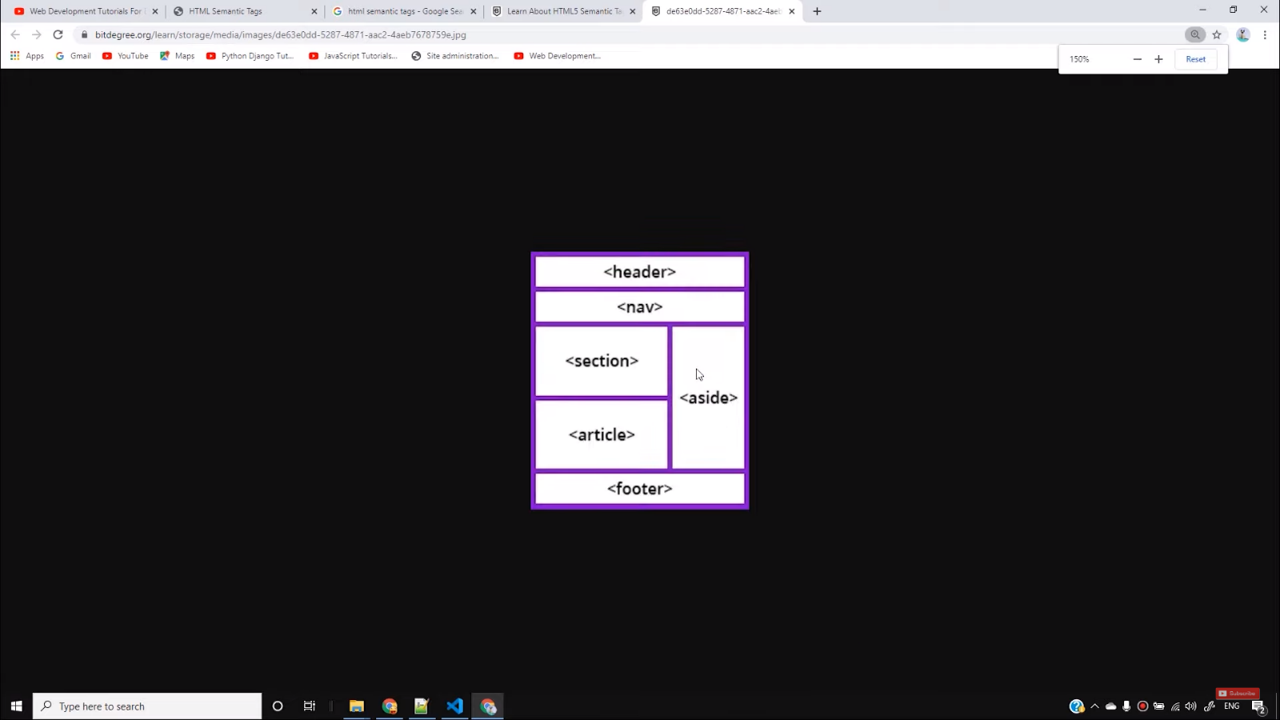

With these examples, the search engines can easily differentiate between headers, navigation bars, sections, bodies, and footers. Also, when we share the link of this website in social media, then the viewers will easily understand headings, sections, and body of a website.

But now the question arises, is it necessary to use all these things? The straight answer is **No**. It is not necessary to use the semantics but including it will help in the SEO part and increase the probability of ranking of your website. If you are working on a blog, then you must use this technique to improve its ranking. On the other hand, non-semantic elements do not justify their meaning. For example, div and span don't tell much what they do apart from the division between texts.

The semantics part in the HTML is not so difficult, therefore without wasting much time we will directly jump on the CSS section where we will learn to make some good looking and real websites. It is always better to learn HTML, CSS, and JavaScript each 75% rather than learning only 100% HTML. You should first try to build the basic foundation of web development and then keep learning step by step through practising. Because you will never be able to learn 100% of web development. Therefore, try to improve skills by practising more.

**Code as described/written in the video**

<!DOCTYPE html>

<html lang="en">

<head>

<meta charset="UTF-8">

<meta name="viewport" content="width=device-width, initial-scale=1.0">

<meta http-equiv="X-UA-Compatible" content="ie=edge">

<title>HTML Semantic Tags</title>

</head>

<body>

<h3>Semantic Elements</h3>

<details>

<summary>I have keys but no doors. I have space but no room. You can enter but can’t leave. What am I?

A keyboard.

A keyboard.

A keyboard.

A keyboard.

A keyboard.

A keyboard.

A keyboard.

A keyboard.

A keyboard.

A keyboard.

A keyboard.

A keyboard.

A keyboard.

A keyboard.

A keyboard.

A keyboard.

A keyboard.

A keyboard.

A keyboard.</summary>

lorem34

</details>

</body>

</html>